Genealogy research, March 19, 2020
Name: Wozniak, Drobiak

Research Highlights

Goal

- Expand the family tree of Gasparius (George) Wozniak and Catharina Drobiak

Following our former correspondence and accepted research plan I focused on the Roman Catholic vital records from Skrzynka. The village of Skrzynka belonged to the Roman Catholic parish in Szczucin.
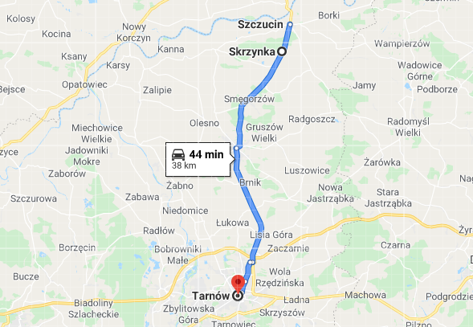

Having only the basic information (picture below) and after careful preliminary analysis I proposed to check the vital records for Skrzynka village that are available in the diocesan archive in Tarnow.

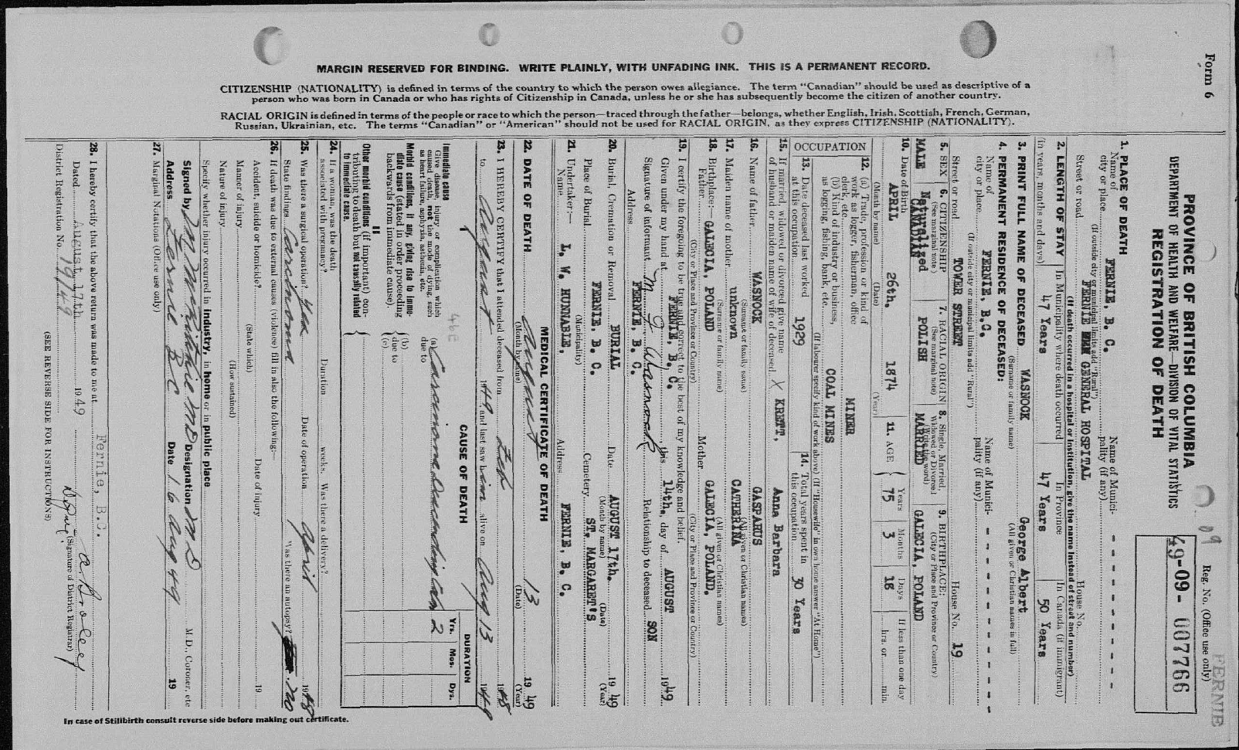

On the next pages you may read results of my work.

Checked years of vital records:

Parish of Szczucin, village Skrzynka

- births 1850 -1889
- marriages 1860 - 1889,

First, I worked with the vital records from the Roman Catholic parish in Szczucin, pages for village of Skrzynka. My first goal was to find a birth record of Andreas and check his parents’ names and additional information that might be on this record.

Kacper (Gasparus) Woźniak was born in Skrzynka in a house number 33 on January 6th, 1856 to:
- Andrzej Woźniak, the son of Sebastian and Jadwiga (Hedvigis) Sajorowna,
- Zofia Tobiasz, the daughter of Marcin (Martinus) and Ewa (Eva) Jurczyk or Jurczykowna (a female form of her surname).
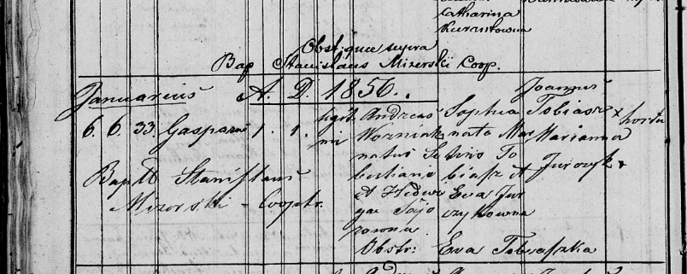

His siblings were:

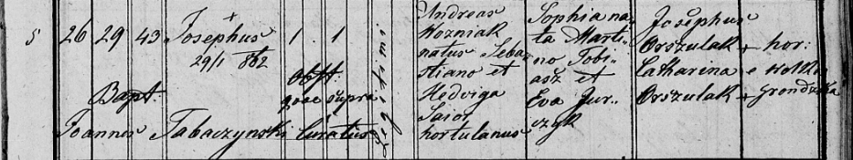
Józef (Josephus) Woźniak born in Skrzynka in a house number 43 on January 26th, 1862.
According to this record, Józef died on January 29th, 1862. The surname of his grandmother, Jadwiga is given as Saior.

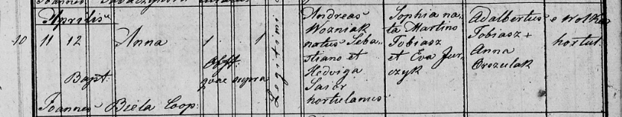
Anna Woźniak was born in Skrzynka on April 11th, 1863.

The other family Wozniak that had children in Skrzynka was Paweł Woźniak. He had following children:

Jan (Joannes) Woźniak was born in Skrzynka in a house number 43 on August 9th, 1876 to:

- Paweł (Paulus) Woźniak, the son of Andrzej and Zofia Tobiasz.

- Agnieszka (Agnes) Gurak or Górak, the daughter of Wojciech (Adalbertus) and Katarzyna Zając.
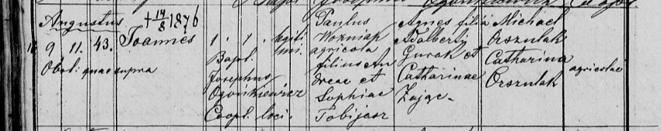

Jan Woźniak died on August 14th, 1876.

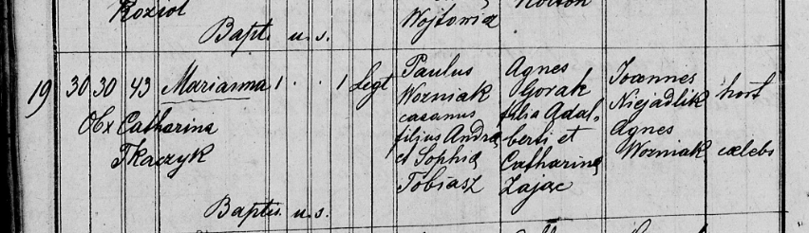
Marianna Woźniak was born in Skrzynka in a house number 43 on October 30th, 1878.

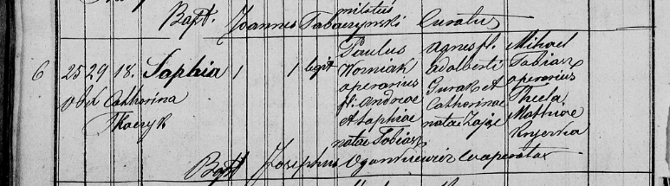
Zofia (Sophia) Woźniak was born in Skrzynka in a house number 18 on February 25th, 1880.

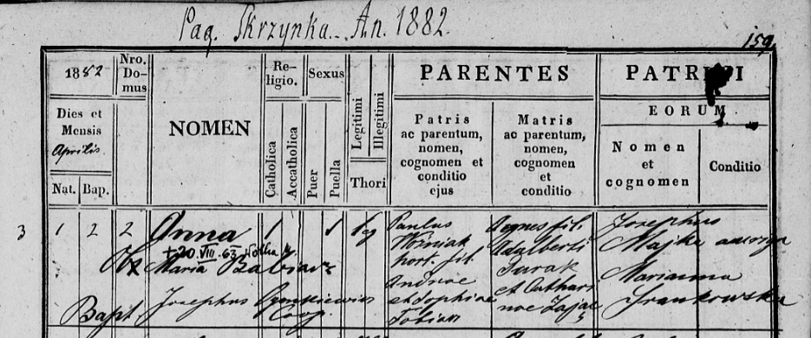
Anna Woźniak was born in Skrzynka in a house number 2 on April 1st, 1882.

Anna Woźniak died on August 20th, 1963.

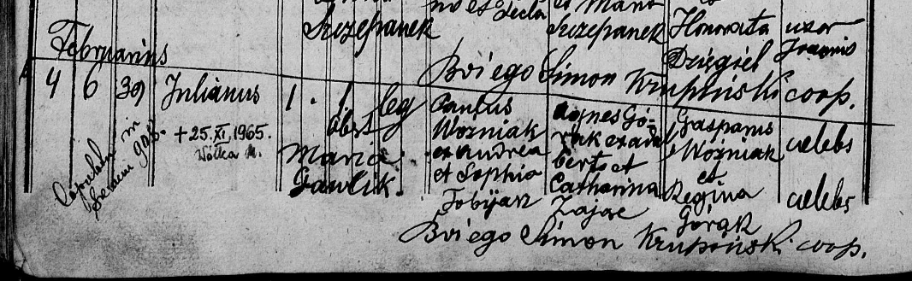
Julian (Julianus) Woźniak was born in Skrzynka in a house number 39 on February 4th, 1884.

Julian Woźniak died in Wólka on November 25th, 1965.

After a longer while, and browsing other pages and books of vital records, I focused on birth records from Wola Mędzrychowska, which is close to Skrzynka.

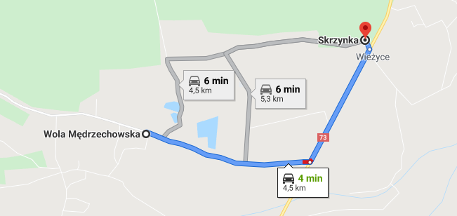

Parish of Wola Mędrzychowska

- births 1858 -1889
- marriages 1870 - 1889,

Katarzyna (Catharina) Drobiak was born in Wola Mądrzechowska in a house number 5 on October 15th, 1858 to:

- Paweł (Paulus) Drobiak, the son of Wawrzyniec (Laurentius) and Agata (Agatha) Bobrowna,

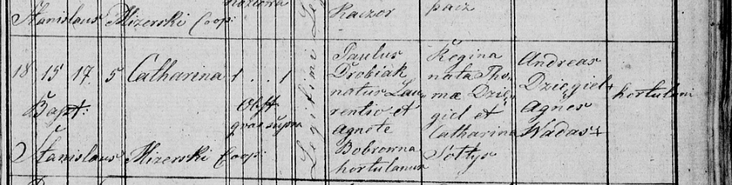
- Regina Dzięgiel, the daughter of Tomasz (Thomas) and Katarzyna Sołtys.

Next, I checked the marriage records from this parish as according to the tradition the marriage supposed to be concluded and registered in the bride’s parish.

Here is what I found.

The marriage concluded on October 11th, 1885 between:

- Kacper (Gasparus) Woźniak, the son of Andrzej and Zofia Tobiasz (here spelt Tobjasz), aged 29,

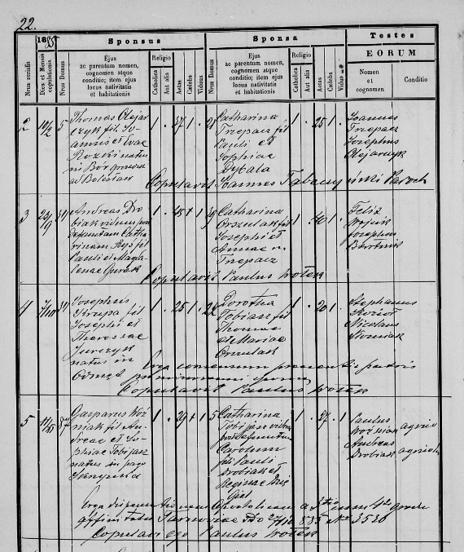
- Katarzyna Tobjasz, the widow of Karol and the daughter of Paweł Drobiak and Regina Dzięgiel, aged 27.

The year of marriage is clear to read. There is no doubt that it is 1885.

The first marriage of Catharina Drobiak was concluded on October 10th, 1882 between:

- Karol (Carolus) Tobiasz, the son of Tomasz and Marianna Orszulak, an army reserve soldier aged 25,

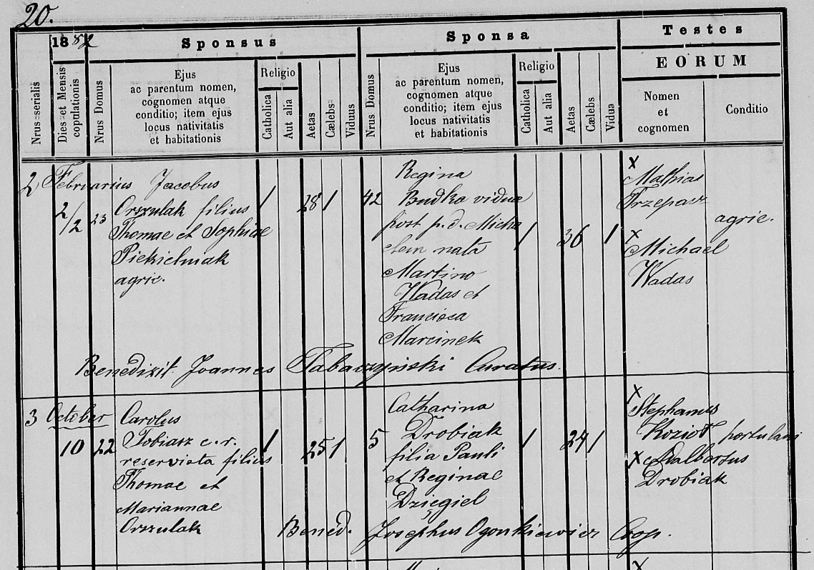
- Katarzyna (Catharina) Drobiak, the daughter of Paweł and Regina Dzięgiel, aged 24.

Results

- The family tree was expanded

