Genealogy research June 2020
Name: Balwierczak/Balwirczak
Destination: Nadolany, Nowotaniec, Pielnia

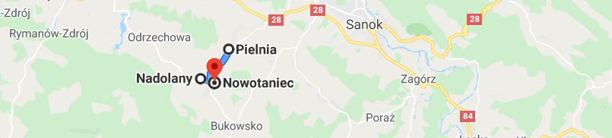

The main goal of the on-site research was to:
- locate where your branch of the Balwierczak Family used to live (houses No. 115 and 76)
- check if there are any descendants of Andrzej Balwierczak & Katarzyna Mołocznik still living there
- check if there might be any graves found in a local cemetery..

First, I visited the local Registry of Vital Records in Bukowsko that keeps books from approximately 1900 till nowadays. I wanted to check the newer books to find any records related to descendants of Andrzej and Katarzyna, who most probably stayed in the area. While going through the records I was paying attention to house No. 115 as that was the last known address of your relatives and as far as I learned, house numbers did not change before WW1 (and probably not before WW2 either).

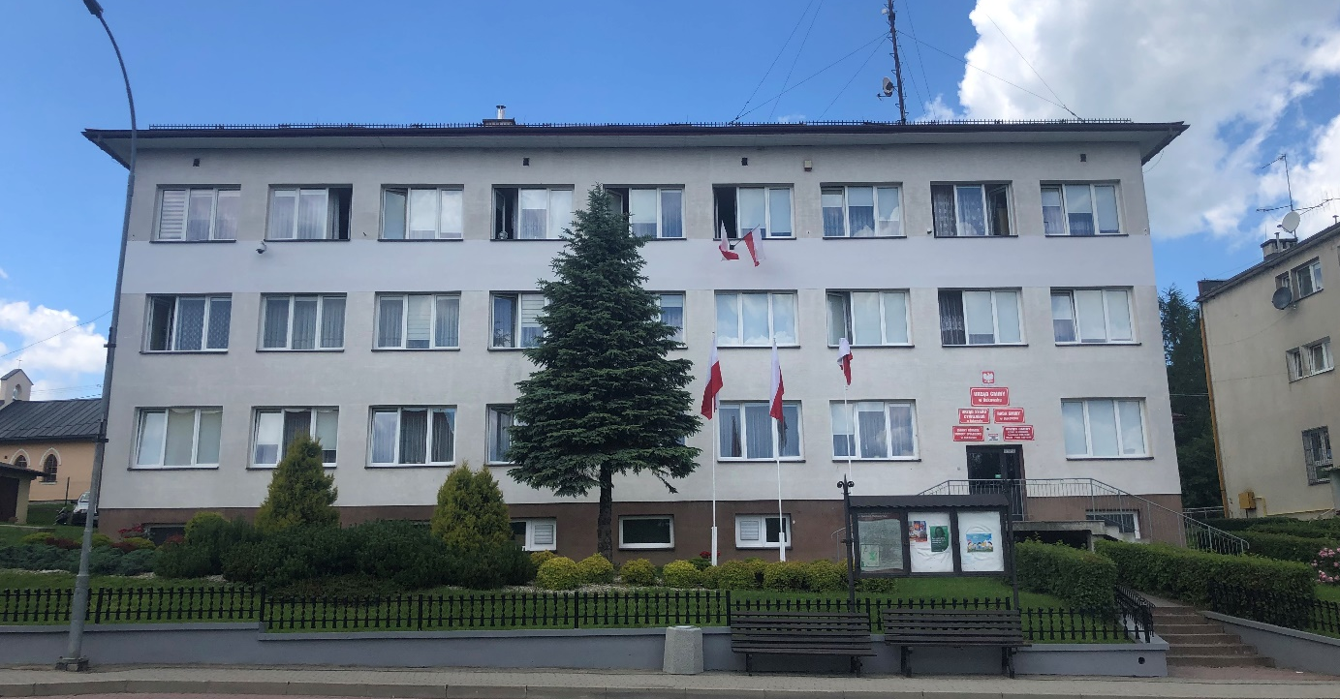

In spite of much effort, I did not find a single record referring to ‘your’ branch of the family.. the last Balwierczak born in the house No. 115 was Bronislawa – a daughter of Andrzej Balwierczak and Maria Chrząszcz, born there on August 16th 1903. We do not know how she fits into the family, unless her mother is listed incorrectly. It looked like your branch of the family ‘vanished’ from that area (what actually fits into one theory I have, but I’ll present it later).

Interestingly, soon after the last ‘known’ Balwierczak was registered in Nadolany #115 in 1903, starting from 1906 – the Kawa Family started to show up in the records – as the residents of Nadolany #115.

It was the family of Michał Kawa & Rozalia Kozimor, who had at least the following children:
  - A stillborn child from 1906
  - Michalina born in 1907. Michalina got married to Piotr Jasiczek in 1933 (and still used the address Nadolany #115 back then)

First, I started with searching for anyone named Balwierczak living in Nadolany.

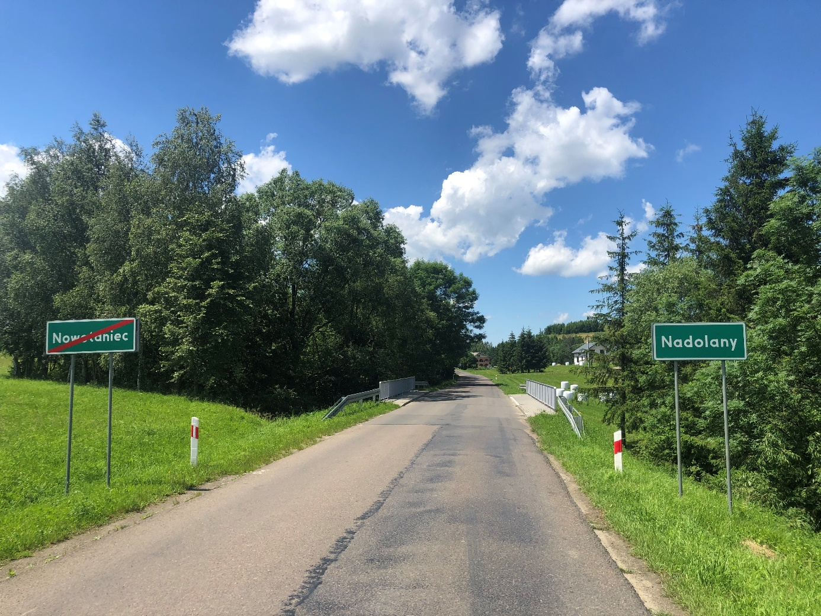

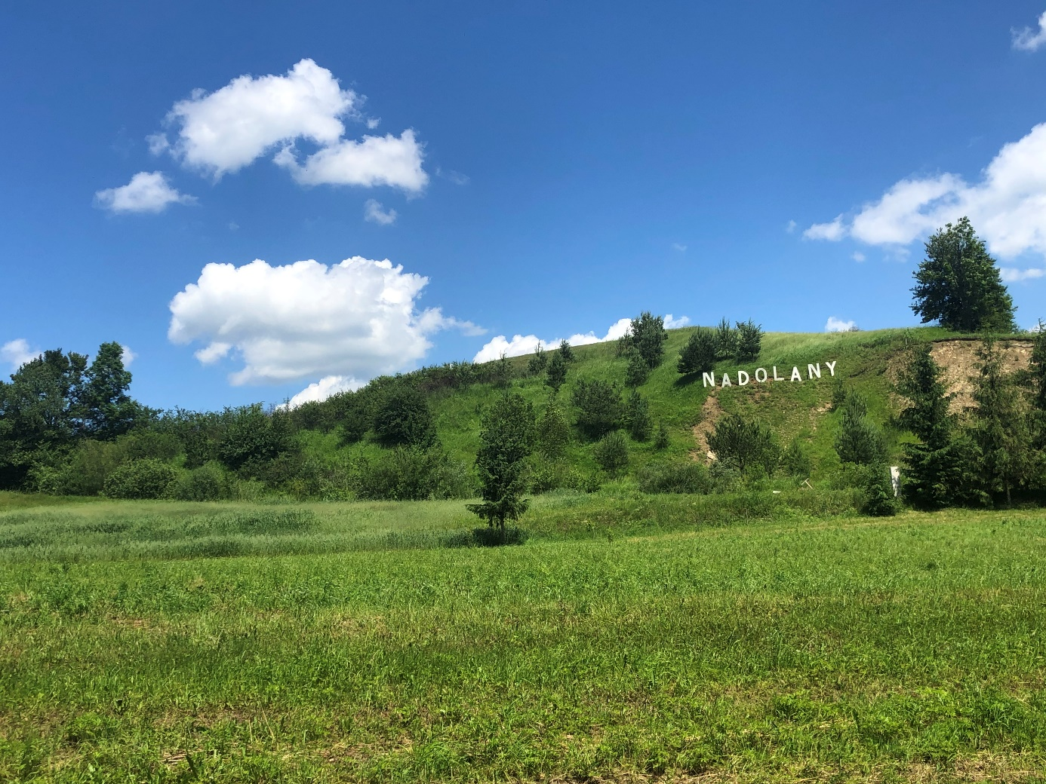
I am not sure if you have seen that Nadolany put a ‘Hollywood’ sign on one of their hills:

I spent a while walking around the village and asked people about the Balwierczak Family. Actually there were 2 Balwierczak Famlies in Nadolany, and one in Nowotaniec. I visited the first one and spent a while trying to trace their ancestry. It was quite a lot of fun as I was asking about 1800’s and people I talked to hardly remembered names of their grandparents. Eventually, I figured out the first family I talked to originated from Nowotaniec (not Nadolany) and was not related to Szymon Balwierczak in any way..

The 2nd man, who interestingly lives in Nadolany #76 (current address) is actually Stanislaw Bawierczak . However, according to most of the people I interviewed, the numeration changed at least twice, so I am not convinced that the current No. 76 refers to the old number from early 1800’s.
The conversation with him was a bit difficult, as he was not fully sober, and kept telling me the story about his 2-year absence that was eventually interrupted by his neighbor’s visit and alcoholic libation that resulted in a hip fracture.. so instead of answering my questions about his heritage, I had to listed his complains about health care system in Poland..

Eventually, with a help of my notes and the previous archive research, we figured out that he is a descendant of Teofil Balwierczak from Nowotaniec – so the fact he lives in Nadolany #76 is just a coincidence.
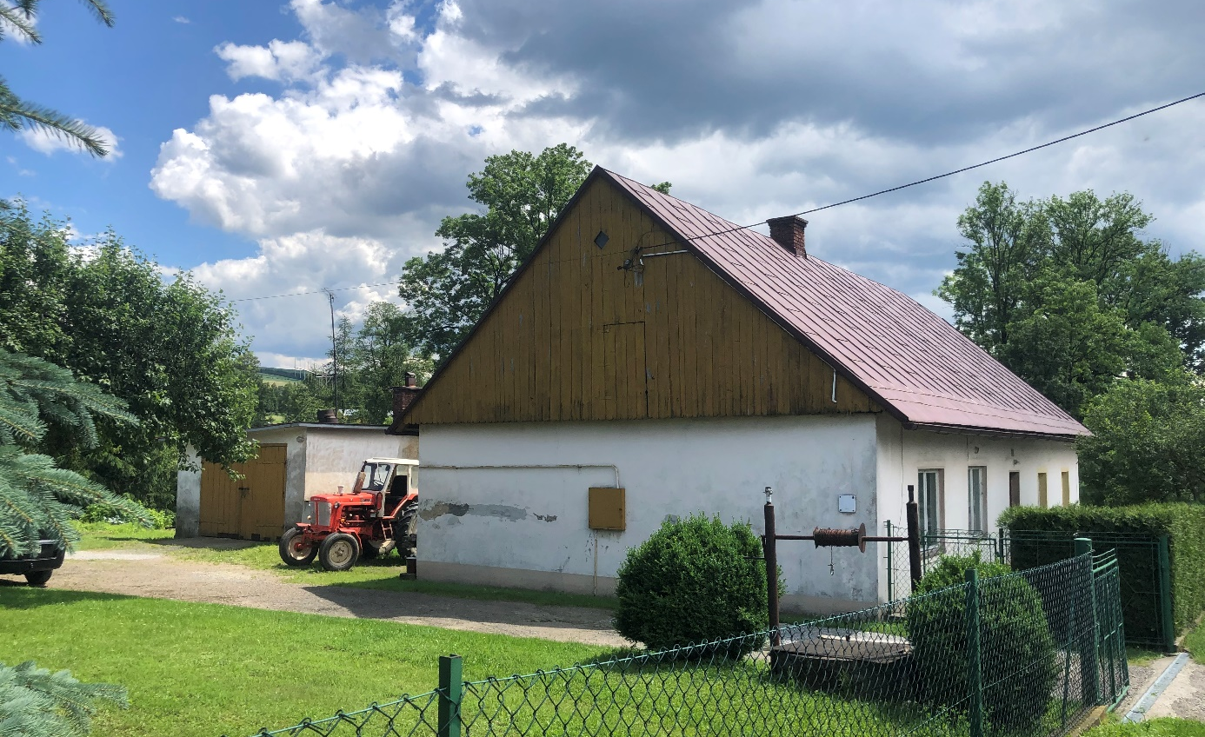
Just in case, the house No. in that case was not changed, I took a photo of his house.

and also, of him (as currently he is the only Balwierczak living in Nadolany)
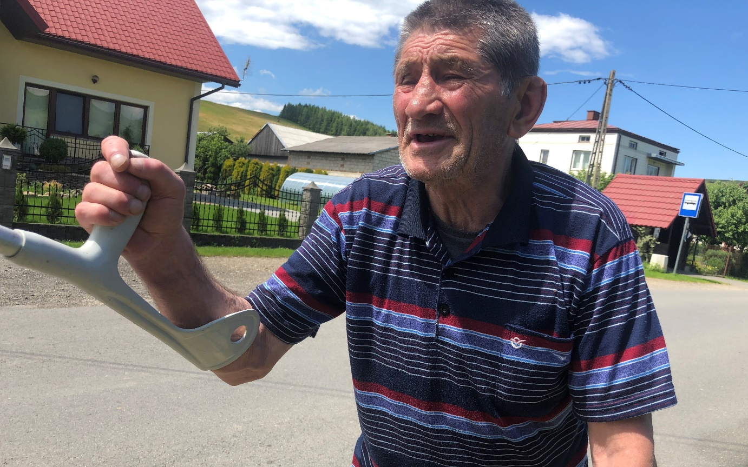

Then, I drove to see the current address Nadolany 115. That house is located on the completely other side of Nadolany than #76. The numbers are not placed there in a raw..
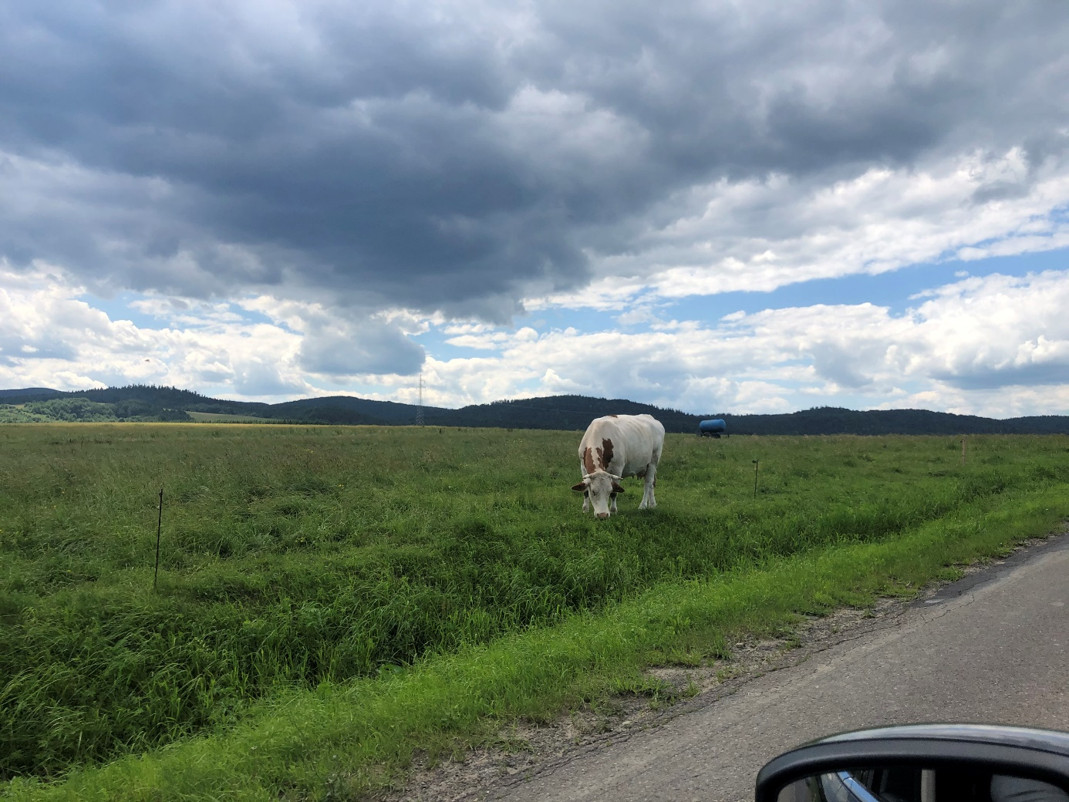
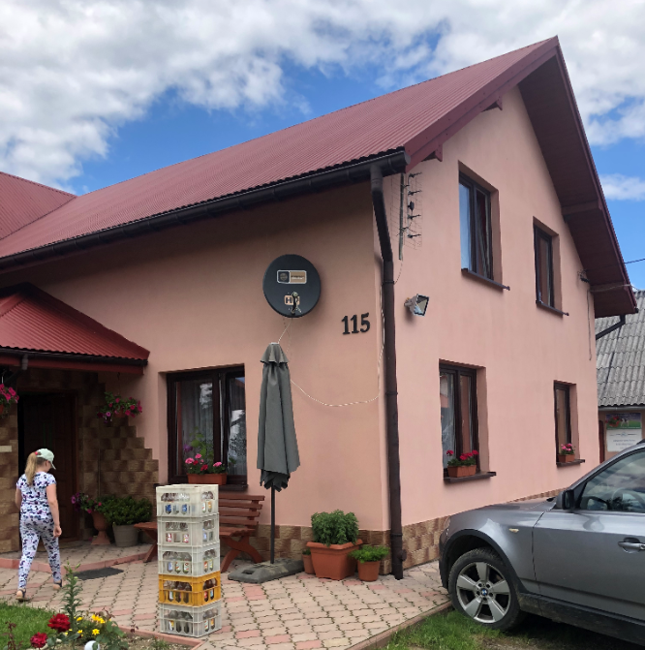
I spent a while talking to an owner of the house No. 115 who was very helpful and explained a lot. His house was built several years ago on an empty spot, almost at the end of the village. According to him, the numbers did not really change but many houses either burned out or collapsed and disappeared, as many people moved out from Nadolany over the years because of wars, diseases, emigration, and natural migration to the towns, etc.. Because of that there were some house numbers that were not in use for some years, and when a

new house was built (like his house) it was given a ‘free’ number.. That makes quite a lot of sense if you consider the fact that house # 12 is next to #136 and opposite the house #54..
Not having found any living descendants of Andrzej & Katarzyna Balwierczak and knowing that house #115 ‘disappeared’ I decided to focus on the Kawka Family – as for some reason they lived in that house from 1906..
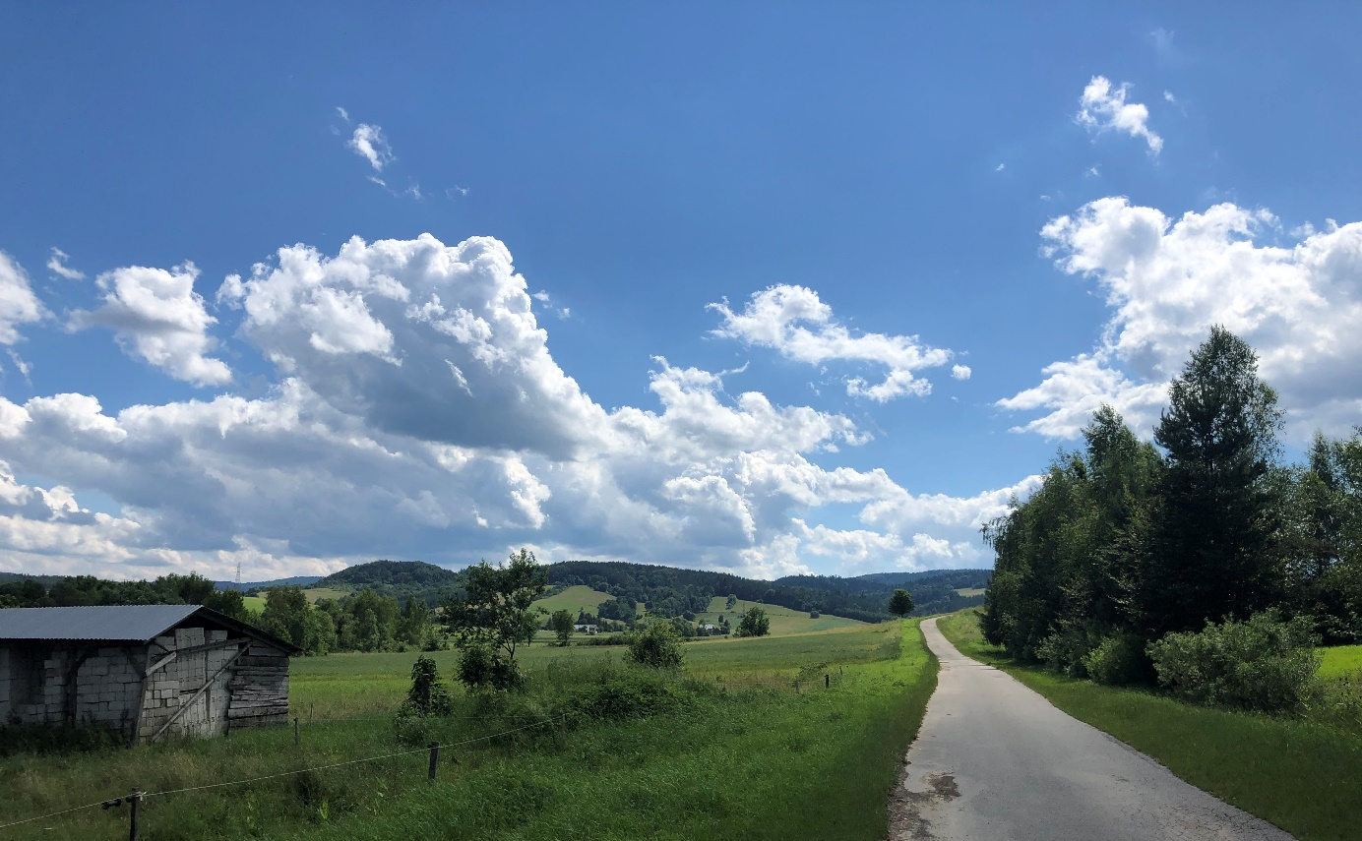
It took me a long time to first identify the descendants of that particular Kawa Family and then found any living relatives. Driving around these village was a pleasure though.

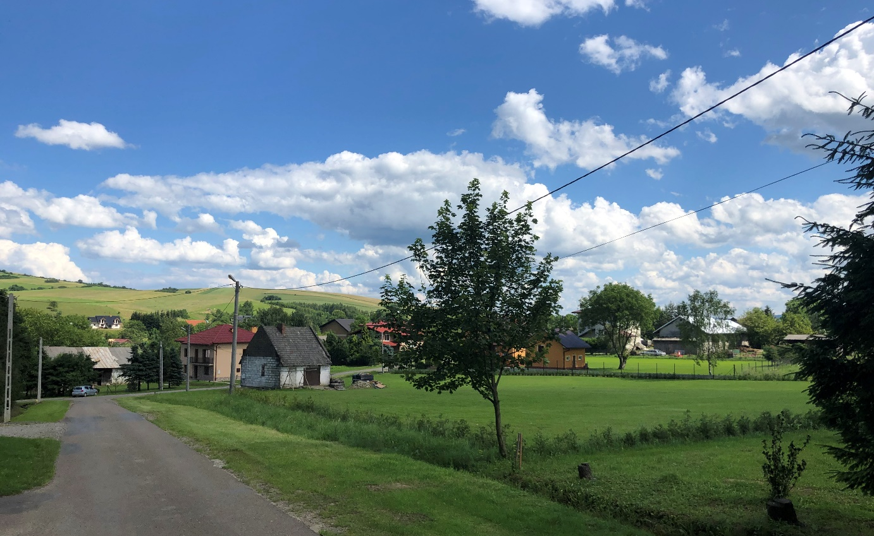

Eventually, after a long time I found the right people to talk to. Their name is also Kawa but they have no idea how they might be related to Michał and Rozalia.. But they knew, where the house was located, and showed me the place. Let me present it to you in a way that would help you understand what that place might have looked like years ago.
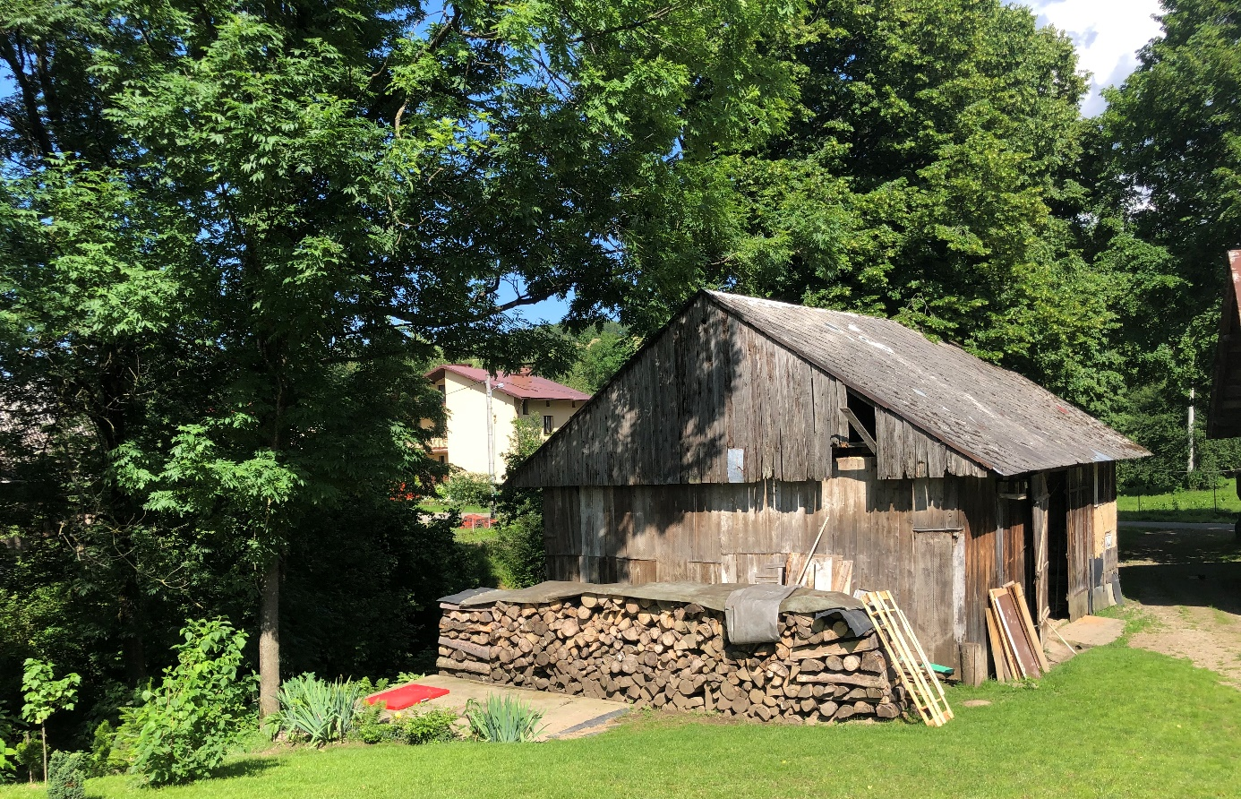
On the back of their house there is an old wooden stable:

Passing it on the right, you get to the little road, with another old, abandoned house on the right:
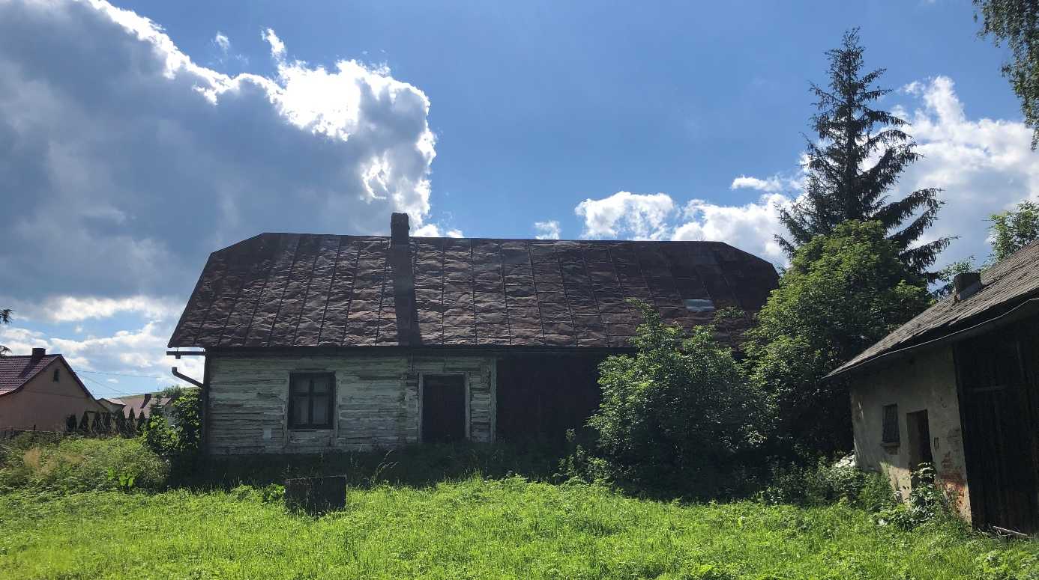
The little road turns to the left, you cross the little bridge over the spring, and there is a field:
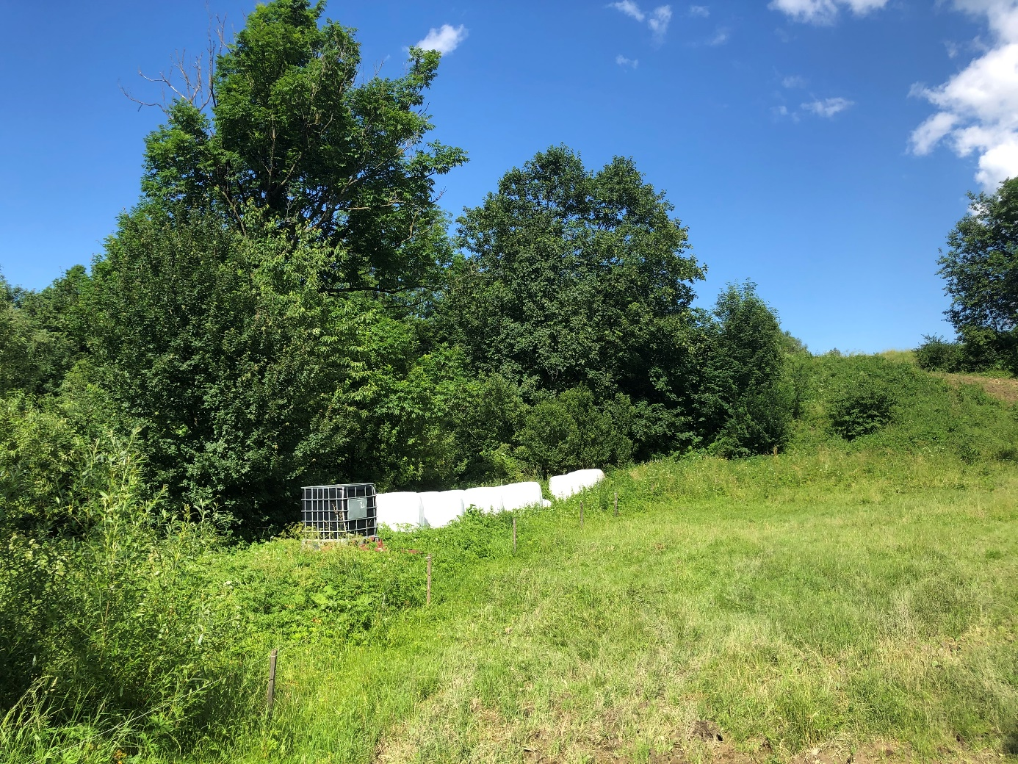
This is exactly where the house #115 was located and where the Kawa Family (Michał and Rozalia) and their children and possibly grandchildren used to live.

It was not only confirmed by the Kawa Family, but also by some neighbors who I also interviewed. They remember the house that was first empty and then burned down. They also recalled it was house No.115 (one of the neighbors said that before hearing my suggestion about the house number). Unfortunately, no one recalls the Balwierczak Family living there, but considering the fact there is no record referring to that family after 1903 – I am not surprised.
There is a great-grandson of Michał Kawa, who most probably lived in that house many years ago and he might know a bit more – but he moved out from that area many years ago. I could probably try to find him if you’d like to hear more about that place…

Taking all the facts and stories into consideration, it is highly possible that your lineage of the Balwierczak Family simply disappeared from Nadolany (otherwise I would have most probably found them). We do not know what happened to all of the children of Andrzej and Katarzyna. The last fact that is proved is a death of Andrzej in 1904. It is possible that Katarzyna (whose death record was not found in Nadolany or Nowotaniec) moved back to her village (Pielnia) that is actually located very close to that place where the house No 115 was located. If there were any young children, they probably moved with her.
That theory matches the fact that the house No. 115 was either sold or given or somehow inherited by the Kawa Family who started to be registered under that address after 1906.
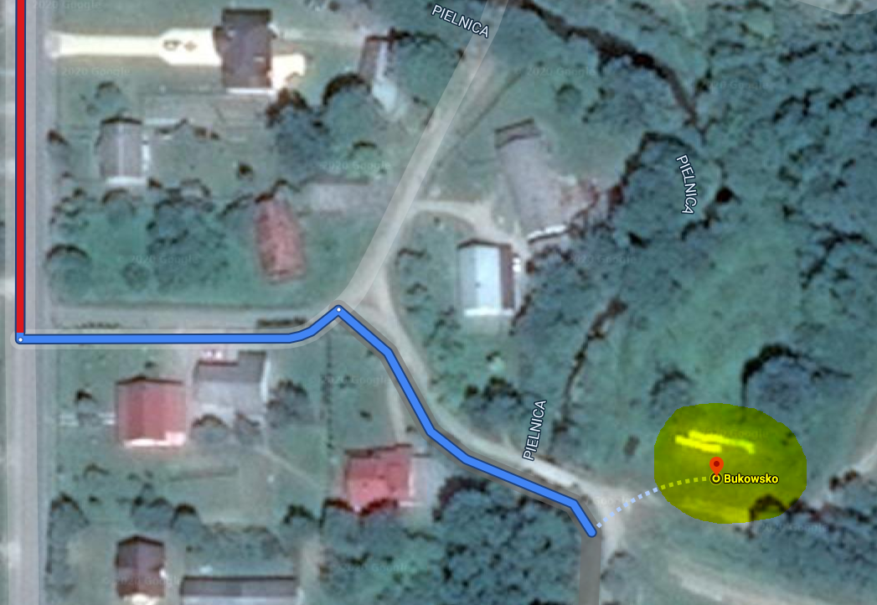
I tried to spot that place on a google map. Please note, it is really close to Pielnia.

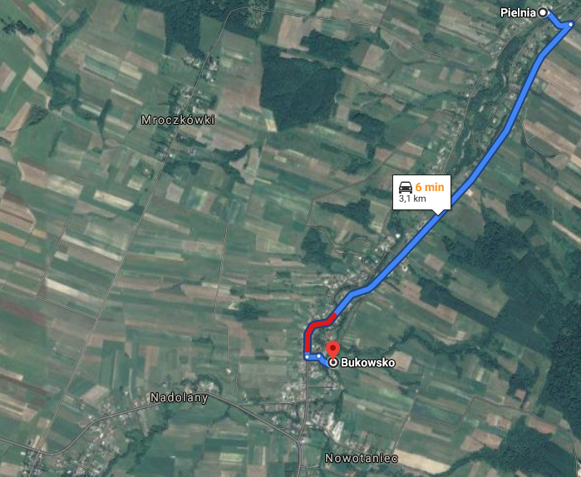

Google marked it as Bukowsko – but this is still Nadolany. Here is the link you can use to zoom it in an out:
https://www.google.pl/maps/dir/Pielnia/49.5171357,22.0340069/@49.5212321,22.0390167,4882m/data=!3m1!1e3!4m9!4m8!1m5!1m1!1s0x473c14a5d8caaaa1:0x23adb74b2f8ccd27!2m2!1d22.0522416!2d49.5368392!1m0!3e0

To the best of my knowledge and experience – this is the place your ancestors originated from..

Since there is no one from your direct family living there, there was most likely no one to take care of the graves. Moreover, the cemetery is indexed and I did not come across any name that would match to your family tree. As the research took almost the whole day, I skipped a visit at the local cemetery.

Instead, I quickly drove to Pielnia – where the Mołocznik Family originated from.

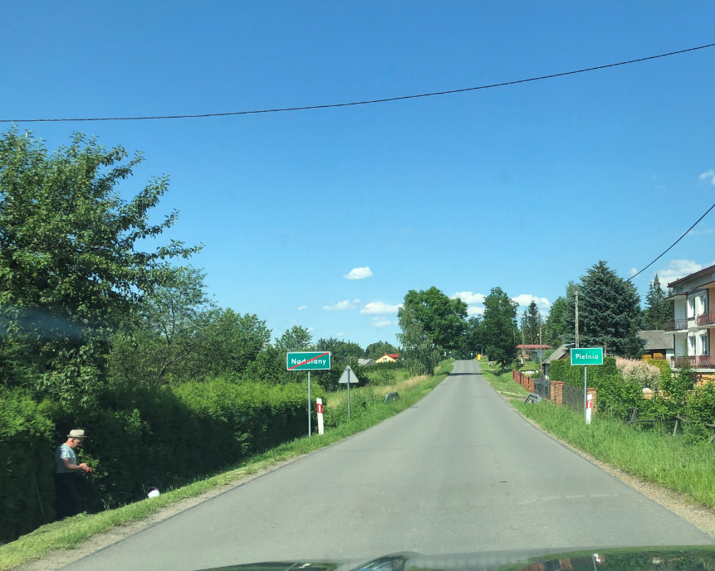
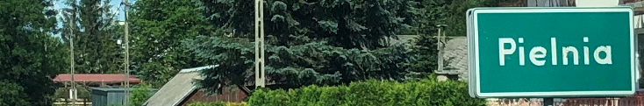

Just after entering that village, on the right hand side there is an old cemetery, located on the hill. Pielnia had its own Greek-Catholic parish and cemetery as nearly the half of population was Greek-Catholics.
Both the church and the cemetery are now converted into Roman-Catholic. Only several old graves survived and are gathered in one part of the cemetery. They are quite characteristic, not only because of the shape material and a Greek-catholic cross, but also the inscription is made in a Cyrillic alphabet. Some of the graves are missing the plaques or headstones.

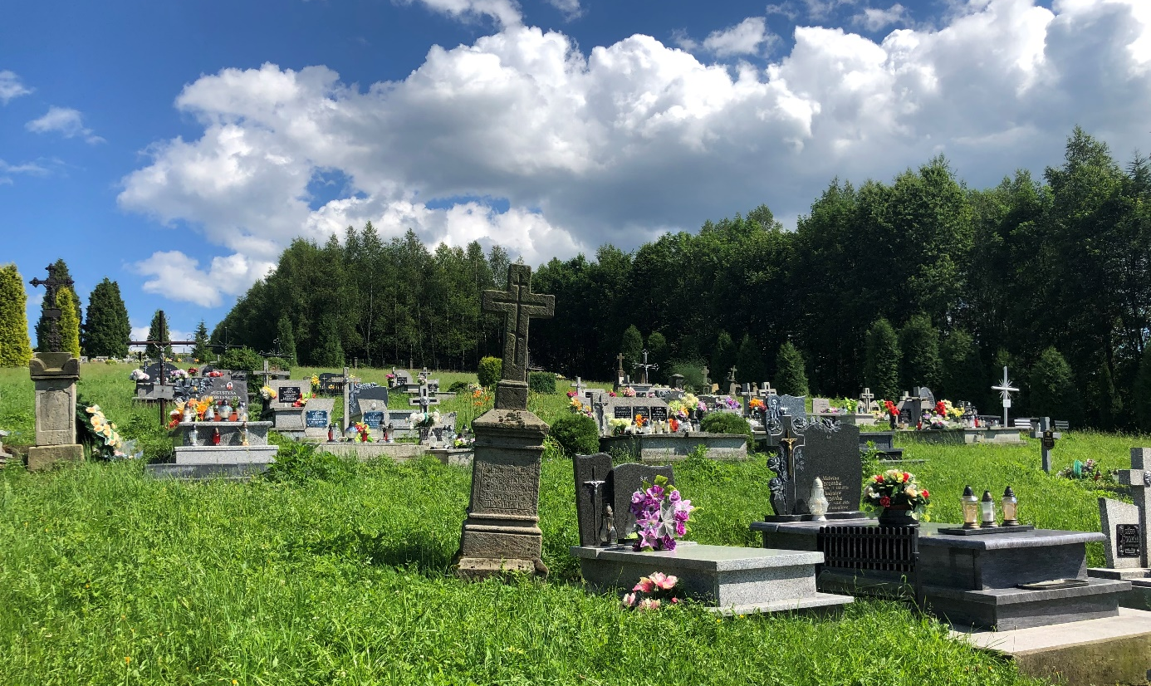
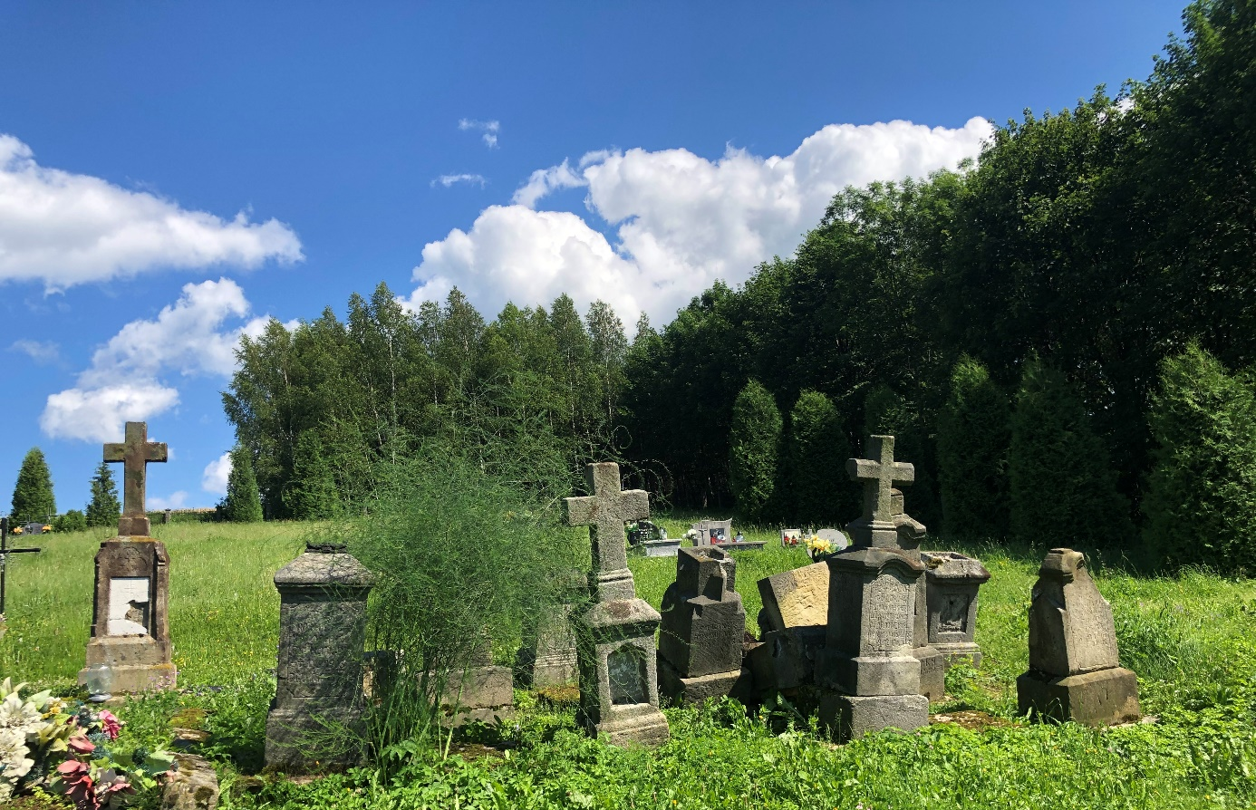

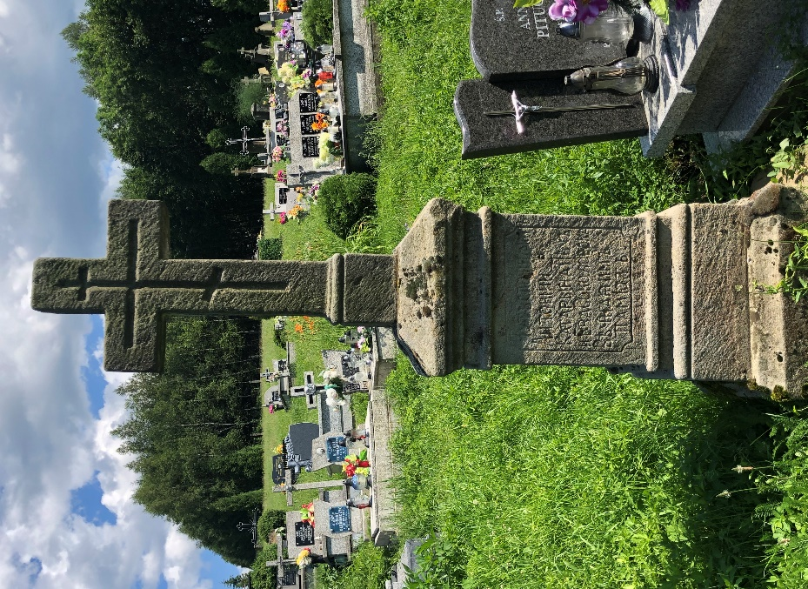
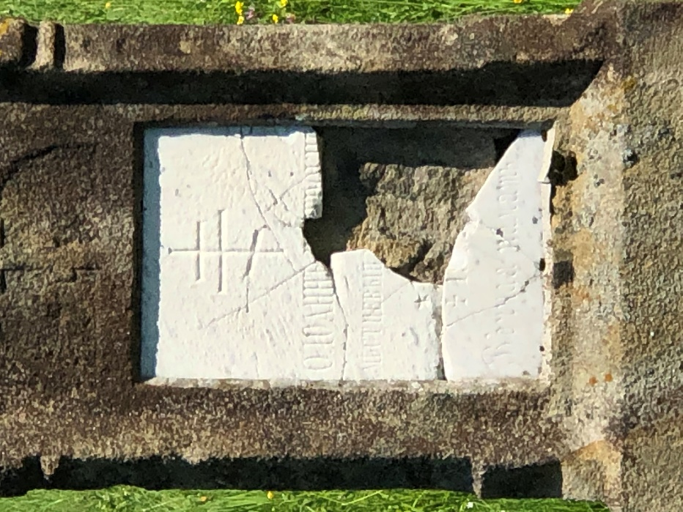
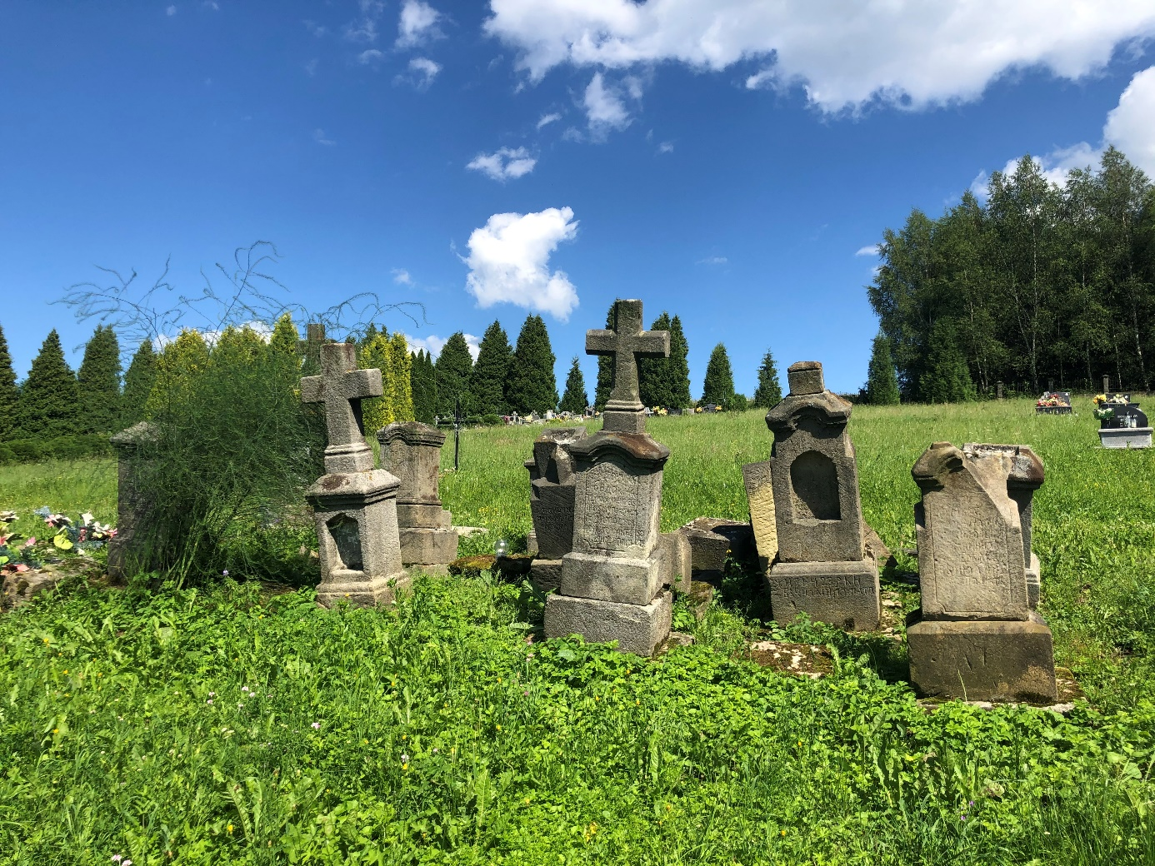

I checked these old gravestones one by one and came across a very valuable one that belongs to Eudoxia nee Molocznikow who died in 1904 at the age of 50 – what matches perfectly to Katrzyna’s sister!
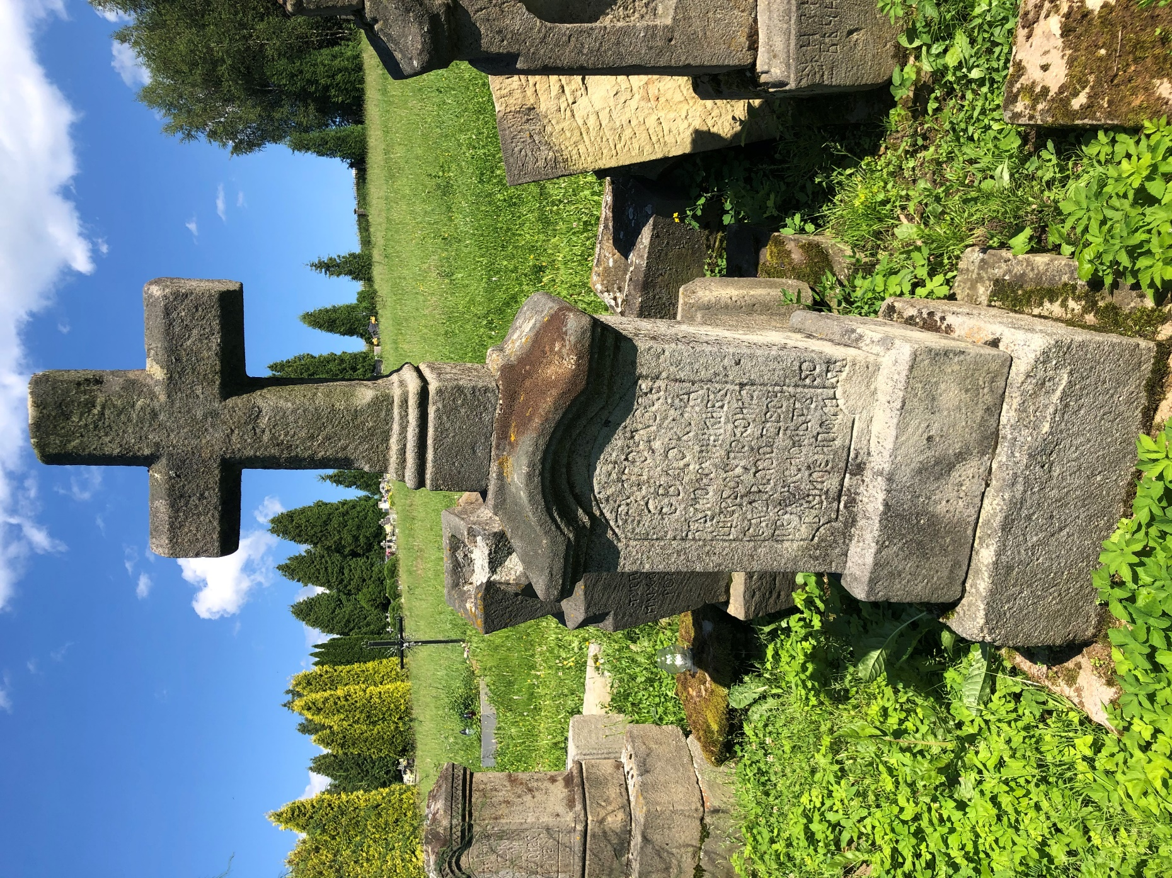

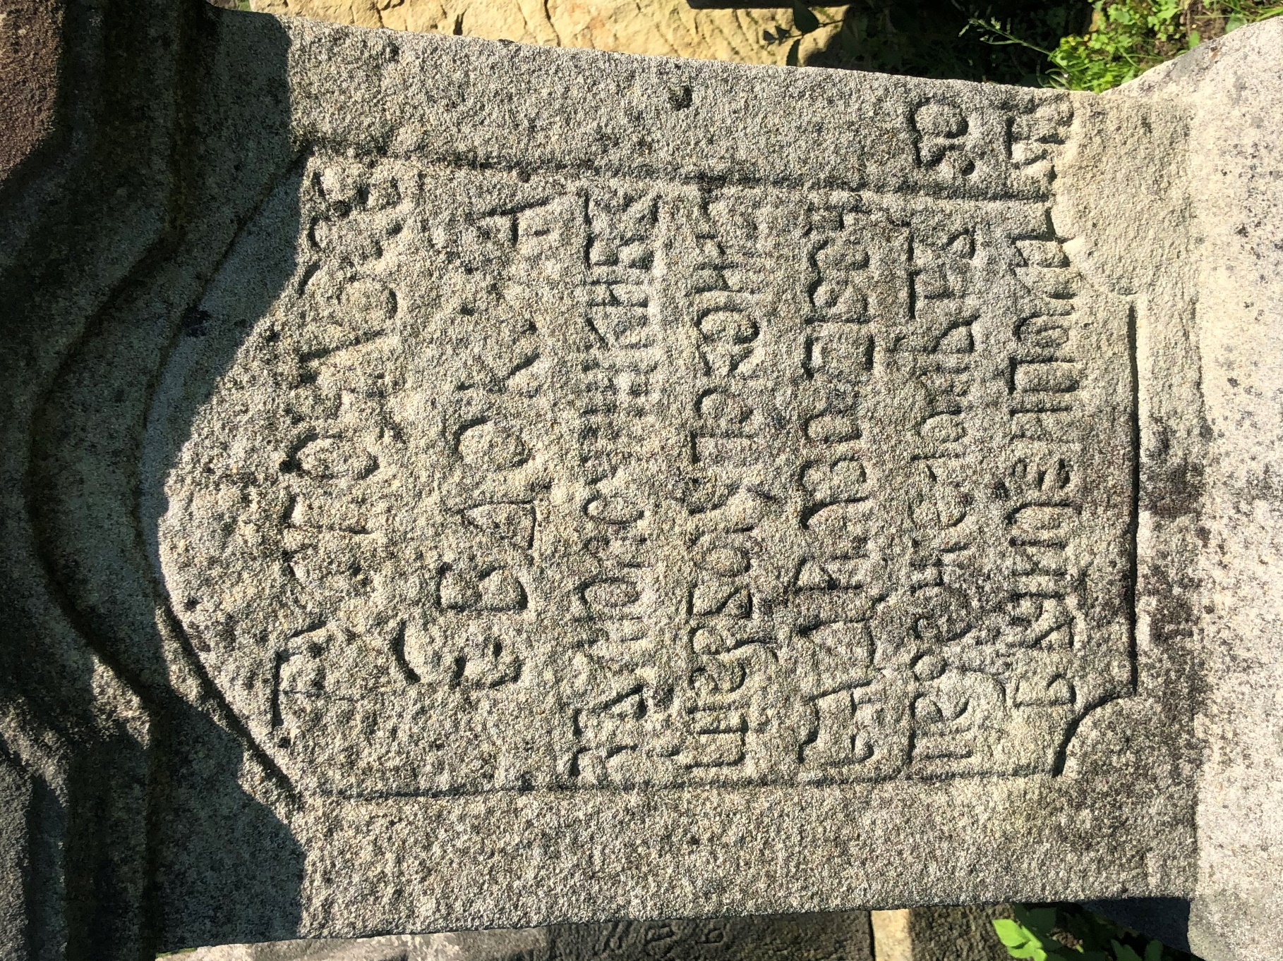

I also took a few pictures of a church in Pilenia where Katarzyna must have been baptized:
