Genealogy research, March 27, 2019
Name: Prokopowicz

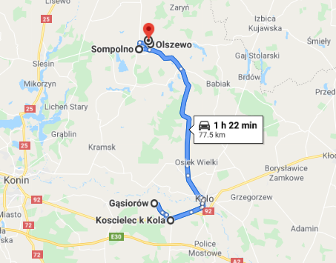

Based on the information you provided us with, I knew your great grandmother Elizabeth Grapkowski (Grabkowski) married Simon Bartosik in 1880 in Sompolno. Elżbieta (Elizabeth) was born around 1863 to Kacper and Emilia and she had a brother Leonard and a sister Anna. Szymon (Simon) and Elżbieta had two daughters: Helena Bartosik born around 1898 and Kazimiera born on May 3rd, 1892.

I started a research by finding their marriage record:

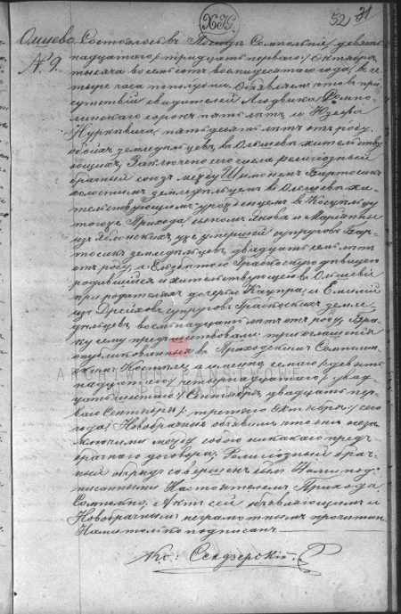
- Szymon Bartosik got married to Elżbieta Grabkowska on October 31st, 1880.

Translation:
Olszewo. It happened in Sompolno on October 19th / 31st, 1880 at 4 p.m. We announce that in the presence of the witnesses: Ludwik Sompoliński aged 45, and Józef Nurkiewicz aged 50, both farmers from Olszewo, a religious marriage was contracted today between:
- Szymon Bartosik, a bachelor, aged 27, born in Kościelec (a village in this parish) and living in Olszewo, a son of Jakub and late Marianna nee Jabłońska, a farmer,
- Elżbieta Grabkowska or Grabkoska (original spelling), a maiden, aged 18, born and living in Olszewo at her parents’, a daughter of Kacper and Emilia nee Dreich (Drajch), both farmers.

3 marriage announcements took place at the local church on September 7th / 19th, 14th / 26th and September 21st / October 3rd this year. The newlyweds confirmed that no marital contract had been concluded between them prior to that date. The current act was read aloud to the present parties and signed by me only as the others are illiterate.

Having learned Szymon Bartosik was born in Kościelec (near Koło), I checked the birth records from the local parish and I found Szymon’s birth certificate:

- Szymon Bartosik was born in Gąsiorów on October 14th, 1853.
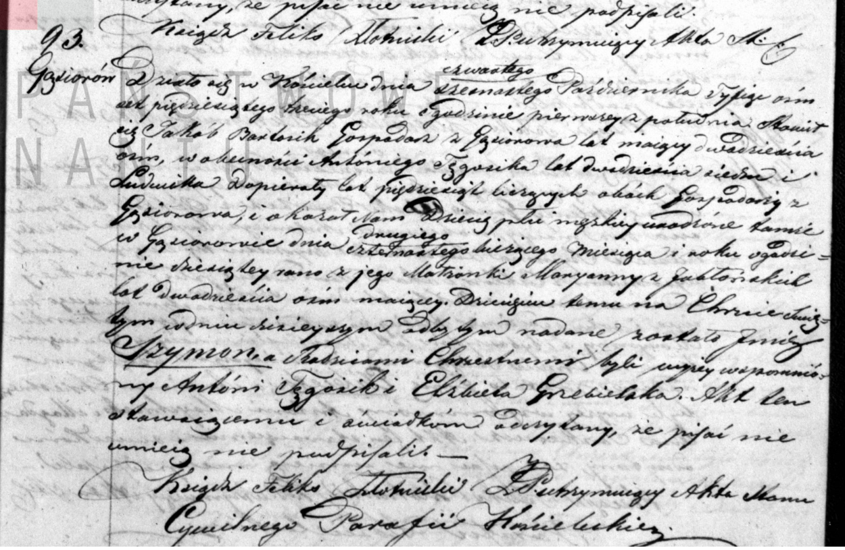

Translation:
It happened in Kościelec on October 4th / 16th, 1853 at 1 p.m. There appeared Jakub Bartosik, aged 28, a farmer in Gąsiorów. In the presence of Antoni Tęgosik, aged 27, and Ludwik Dopierała, aged 50, both farmers in Gąsiorów, he presented a male infant and announced that he was born in Gąsiorów on October 2nd / 14th this year at 10 a.m. to his wife Maryanna (Marianna) nee Jabłońska, aged 28. The child was given a name Szymon. His godparents were: Antoni Tęgosik and Elżbieta Grzebielska. The current act was read aloud and signed by me only as the others are illiterate.

Then I found the marriage records of Szymon’s parents:

- Jakub Bartosik got married to Maryanna Jabłońska on February 4th, 1850.
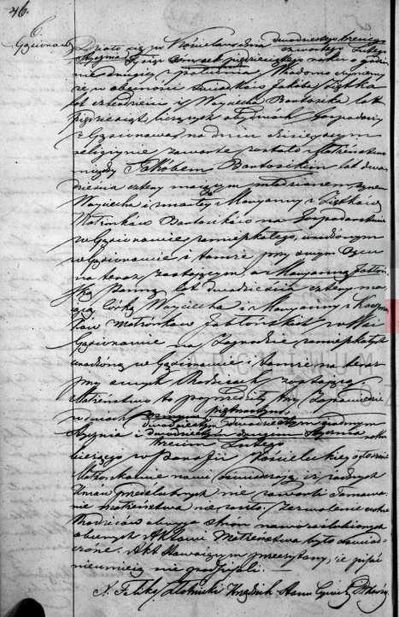

Translation:
It happened in Kościelec on January 23rd / February 4th, 1850 at 2 p.m. We announce that in the presence of the witnesses: Jakub Ziętek aged 40, and Wojciech Bartosik aged 50, both farmers from Gąsiorów, a religious marriage was contracted today between:
- Jakub (Jakób) Bartosik, a bachelor, aged 24, born and living in Gąsiorów at his father’s, a son of Wojciech and late Marianna nee Ziętek,
- Marianna (Maryanna) Jabłońska a maiden, aged 24, born and living in Gąsiorów at her parents’, a daughter of Wojciech and Marianna nee Kacprzak.

3 marriage announcements took place at the local church on January 8th / 15th, January 20th / 27th and January 22nd / February 3rd this year. The newlyweds confirmed that no marital contract had been concluded between them prior to that date. The current act was read aloud to the present parties and signed by me only as the others are illiterate

The next interesting records I came across were the birth certificates of Jakób Bartosik and Marianna Jabłońska. These documents gave us the names of further ancestors.

Jakób Bartosik was born in Gąsiorów in 1824:
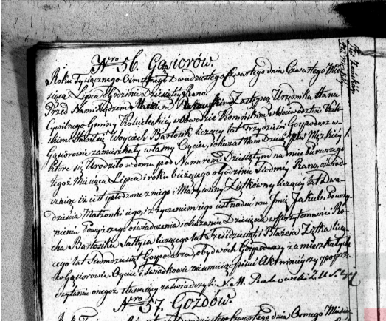
- Jakób (modern spelling: Jakub) Bartosik was born in Gąsiorów on July 1st, 1824.

Translation:
56. Gąsiorów. It happened on July 4th, 1824 at 9 a.m. Before me Fr. Maciej Rakowski, deputy registrar in Kościelec, Konin Area, Kaliskie Voivodeship, there appeared Wojciech Bartosik, aged 30, a farmer in Gąsiorów. He presented a male infant and announced that he was born in Gąsiorów in a house number 10 on July 1st this year at 7 a.m. to his wife Maryanna (Marianna) nee Ziętek, aged 20. The father wished him to be named Jakub. The witnesses to the registration were: Roch Bartosik, aged 60, a village chief and Błażej Ziętek, aged 70, a farmer, both Gąsiorów residents. The current act was read aloud and signed by me only as the others are illiterate.

Maryanna Jabłońska was born in Gąsiorów also in 1824:
- Maryanna Jabłońska was born in Gąsiorów on June 22nd, 1824.
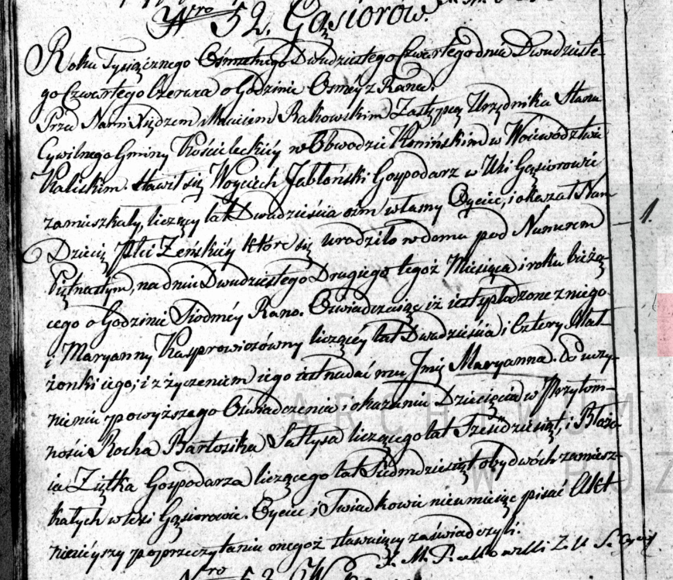

Translation:
It happened on June 24th, 1824 at 8 a.m. Before me, Father Marcin Rakowski, deputy registrar in Kościelec, Kaliskie Voivodeship, there appeared Wojciech Jabłoński, aged 28, a farmer in Gąsiorów, the father of the child. He presented a female infant and announced that she was born in Gąsiorów on June 22nd this year at 7 a.m. to his wife Maryanna (Marianna) nee Kasprowiczówna, aged 24. The father of the child wished the girl to be named Marianna. The child was registered in the presence of Roch Bartosik, the village chief, aged 60 and Błażej Ziętek, aged 70, a farmer, both of them Gąsiorów residents. The current act was read aloud and signed by me only as the others are illiterate.

Then I found a birth certificate of Elżbieta Grabkowska, interestingly among the indexes she appeared as Grabkowska, but the birth record says her father’s name was Markowski…

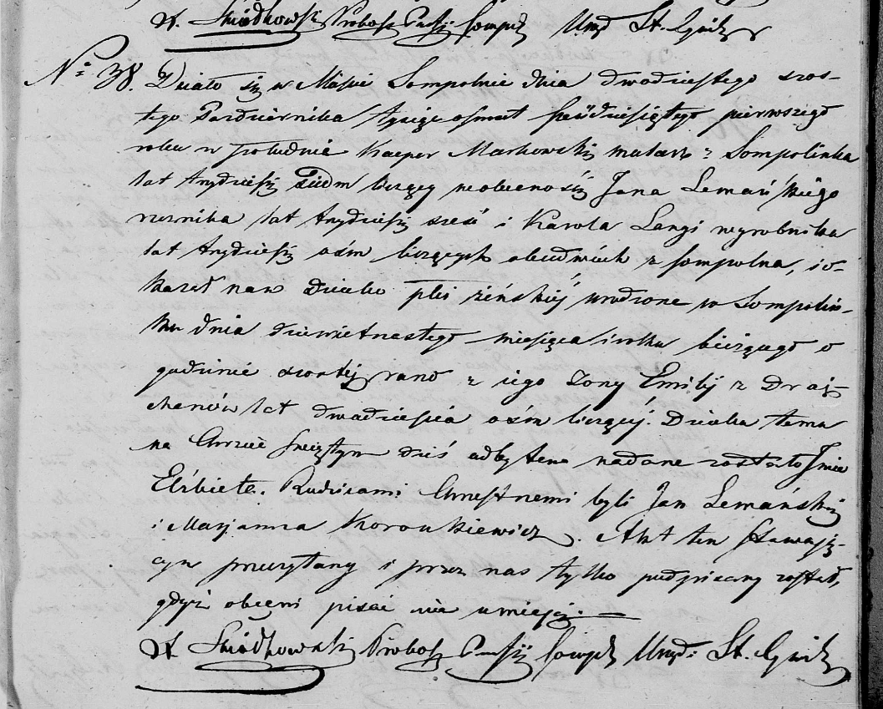
- Elżbieta Grabkowska was born in Sompolno on October 19th, 1861.

Translation:
It happened in Sompolno on October 26th, 1861 at p.m. There appeared Kacper Markowski, aged 37, a house painter in Sompolno. In the presence of Jan Lemański, aged 36, a butcher, and Karol Larga, aged 58, a physical worker, both Sompolno residents, he presented a female infant and announced that she was born in Sompolno on October 19th, this year at 6 a.m. to his wife Emilia nee Drajcher, aged 28. The child was given a name Elżbieta. Her godparents were: Jan Lemański and Marianna Koronkiewicz. The current act was read aloud and signed by me only as the others are illiterate.

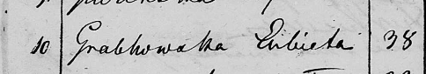
This is an index of the same record:

Furthermore, I found Elżbieta’s siblings:
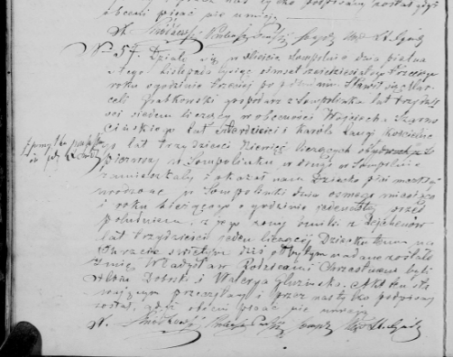
- Władysław Grabkowski was born in Sompolinek on November 8th, 1863.

Translation:
It happened in Sompolno on November 15th, 1863 at 3 p.m. There appeared Marceli Grabkowski, aged 37, a farmer in Sompolinek. In the presence of Wojciech Szurmciński, aged 40, and Karol Larga, aged 39, a verger, both Sompolinek and Sompolno residents respectively, he presented a male infant and announced that he was born in Sompolinek on November 8th, this year at 11 a.m. to his wife Emilia nee Dejchen, aged 31. The child was given a name Władysław. His godparents were: Albin Dobrski and Waleria Gluzińska. The current act was read aloud and signed by me only as the others are illiterate.

Father is called Marceli here.

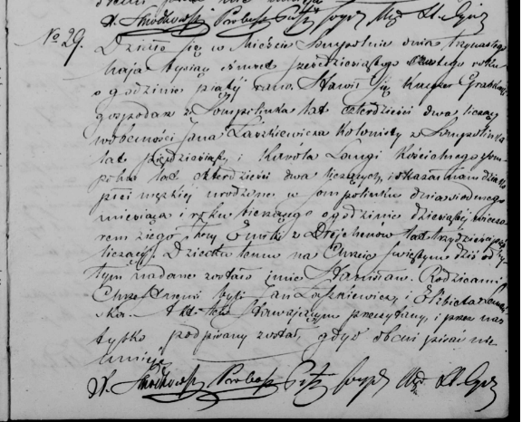
- Stanisław Grabkowski was born in Sompolinek on May 7th, 1866.

Translation:
It happened in Sompolno on May 13th, 1866 at 5 a.m. There appeared Kacper Grabkowski, aged 42, a farmer in Sompolinek. In the presence of Jan Łaszkiewicz, aged 50, a settler-farmer and Karol Larga, aged 42, a verger, both Sompolinek and Sompolno residents respectively, he presented a male infant and announced that he was born in Sompolinek on May 7th, this year at 10 p.m. to his wife Emilia nee Drejchen, aged 35. The child was given a name Stanisław. His godparents were: Jan Łapniewicz and Elżbieta Lemańska. The current act was read aloud and signed by me only as the others are illiterate.

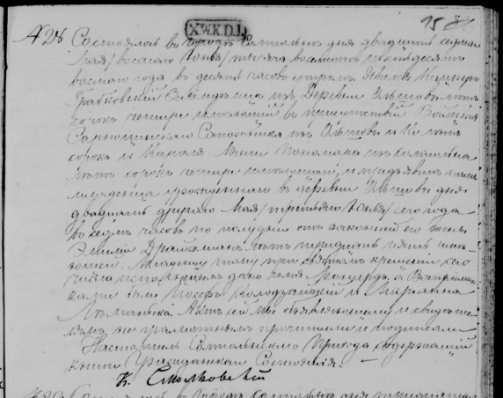
- Leonard Grabkowski in Olszewo on June 3rd, 1868.

Translation:
It happened in Sompolno on May 27th / June 8th, 1868 at 10 a.m. There appeared Kacper Grabkowski, aged 44, a farmer in Olszewo (now a part of Sompolinek). In the presence of Wojciech Sarnoszyński, aged 40, a shoe-maker from Olszewo and Karol Junsz, aged 44, a farmer, he presented a male infant and announced that he was born in Olszewo on May 22nd / June 3rd this year at 7 p.m. to his wife Emilia nee Drajchman, aged 35. The child was given a name Leonard. His godparents were: Józef Kołodziński and Marianna Lemańska. The current act was read aloud and signed by me only as the others are illiterate.

- Joanna Grabkowska was born in Olszewo on August 15th, 1872.
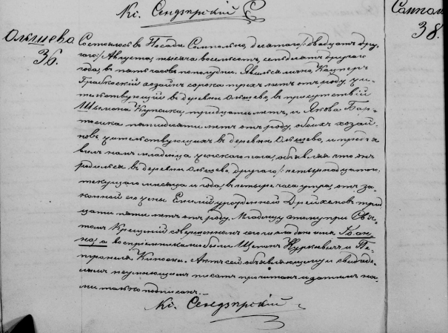

Translation:
It happened in Sompolno on August 10th / 22nd, 1872 at 5 p.m. There appeared Kacper Grabkowski, aged 43, a farmer in Olszewo (now a part of Sompolinek). In the presence of Szymon Kupsik, aged 30, and Jakub Bartosik, aged 50, both farmers in Olszewo, he presented a female infant and announced that she was born in Olszewo on August 2nd / 15th this year at 4 a.m. to his wife Emilia nee Drajchman, aged 35. The child was given a name Joanna. Her godparents were: Szymon Kurkiewicz and Petronela Kiposka. The current act was read aloud and signed by me only as the others are illiterate.

